


Chapter Quiz

Coding and Programming


Quiz

Chapter 4 For Student

ⓒ2023 SAMSUNG. All rights reserved.
Samsung Electronics Corporate Citizenship Office holds the copyright of this document.
This document is a literary property protected by copyright law so reprint and reproduction without permission are prohibited.
To use this document other than the curriculum of Samsung innovation Campus, you must receive written consent from copyright holder.

Samsung Innovation Campus 2

UNIT 22 Chapter 4 Quiz Stack

Q. 22-01

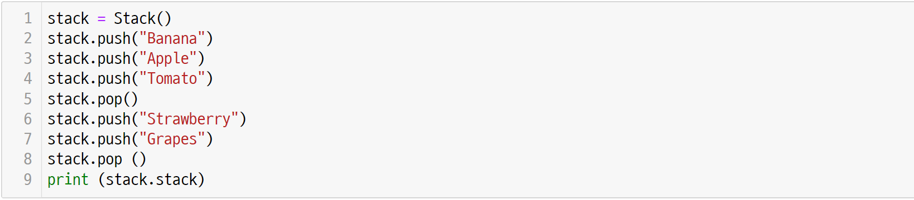
The following is the implantation of stack. What will be the output of the code below?

Samsung Innovation Campus
Chapter 4. Algorithm 1 - Data Structures 3

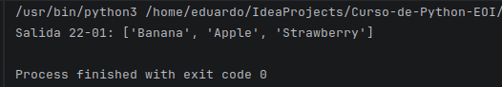

UNIT 22 Chapter 4 Quiz Stack

Q. 22-02

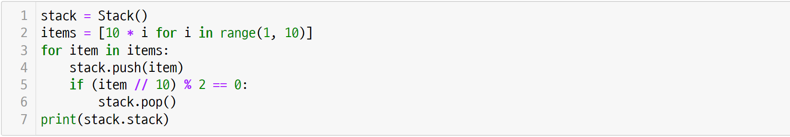
The following is the implantation of stack. What will be the output of the code below?

Samsung Innovation Campus Chapter 4. Algorithm 1 - Data Structures 4

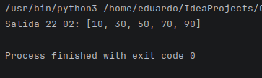

UNIT 23 Chapter 4 Quiz Queue

Q. 23-01

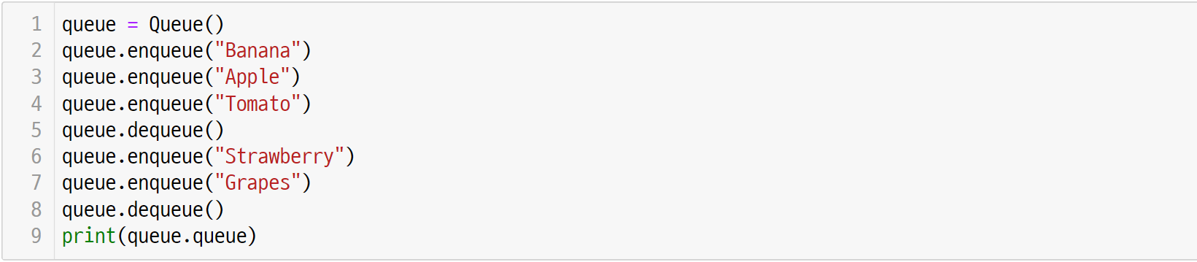
This is the implementation of queue. What will be the output of the code below?

Samsung Innovation Campus Chapter 4. Algorithm 1 - Data Structures 5

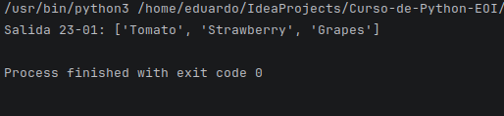
UNIT 23 Chapter 4 Quiz Queue

Q. 23-02

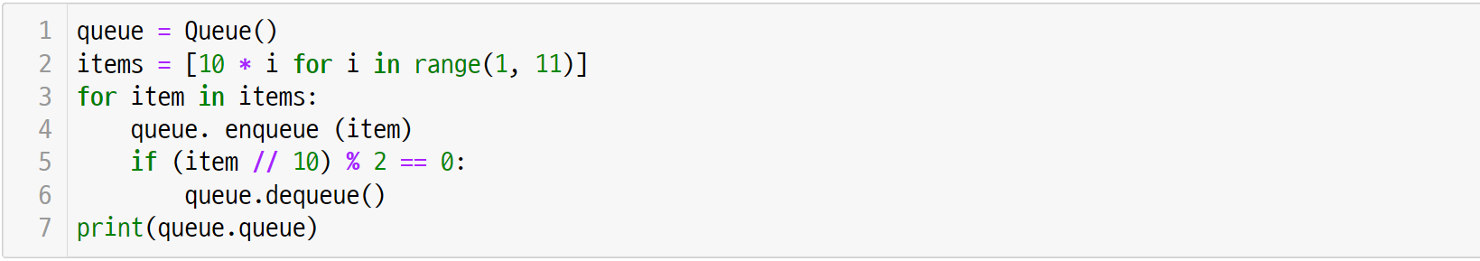
This is the implementation of queue. What will be the output of the code below?

Samsung Innovation Campus Chapter 4. Algorithm 1 - Data Structures 6

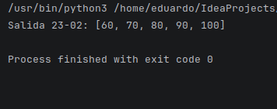
UNIT 24 Chapter 4 Quiz Sequential Search

Q. 24-01

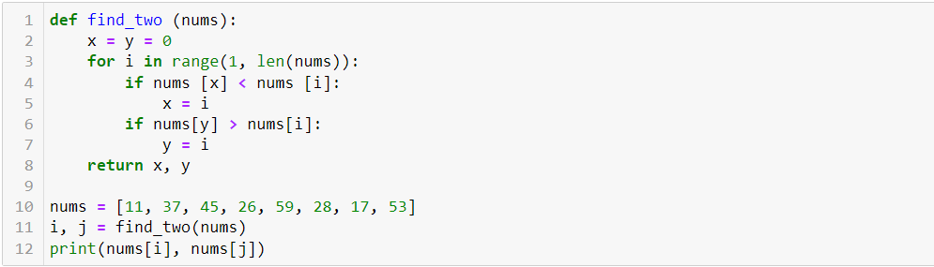
What does the algorithm of the find_two() function below do? Analyze the code and write the execution result.

Samsung Innovation Campus Chapter 4. Algorithm 1 - Data Structures 7

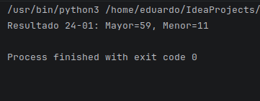

UNIT 24 Chapter 4 Quiz Sequential Search

Q. 24-02

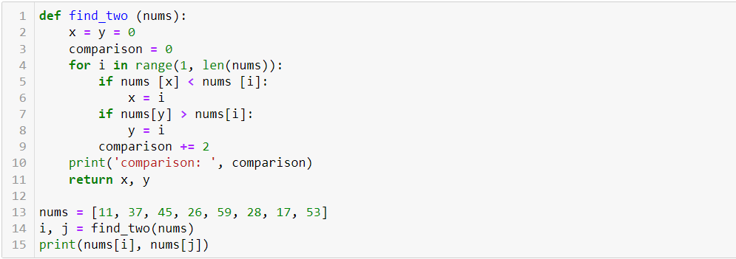
How many comparisons should the find_two() function perform?

Samsung Innovation Campus Chapter 4. Algorithm 1 - Data Structures 8

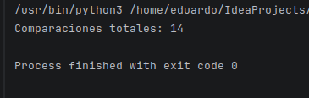

UNIT 25 Chapter 4 Quiz Binary Search

Q. 25-01

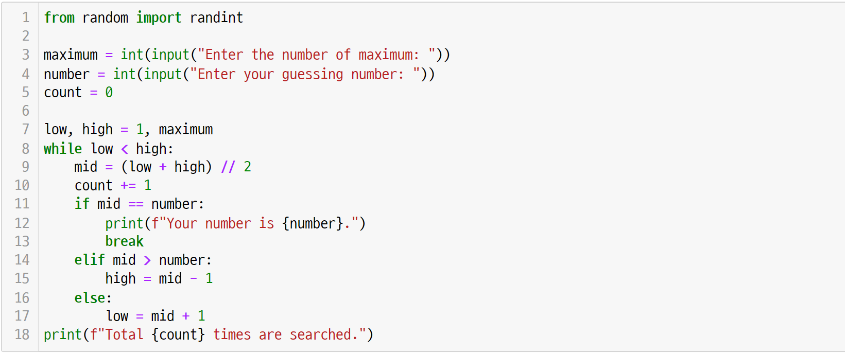
The following is the code for the number matching game. If the maximum is 100 and the number is 51, what is the output of count?

Samsung Innovation Campus Chapter 4. Algorithm 1 - Data Structures 9

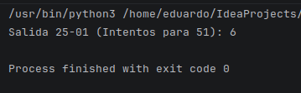

UNIT 25 Chapter 4 Quiz Binary Search

Q. 25-02

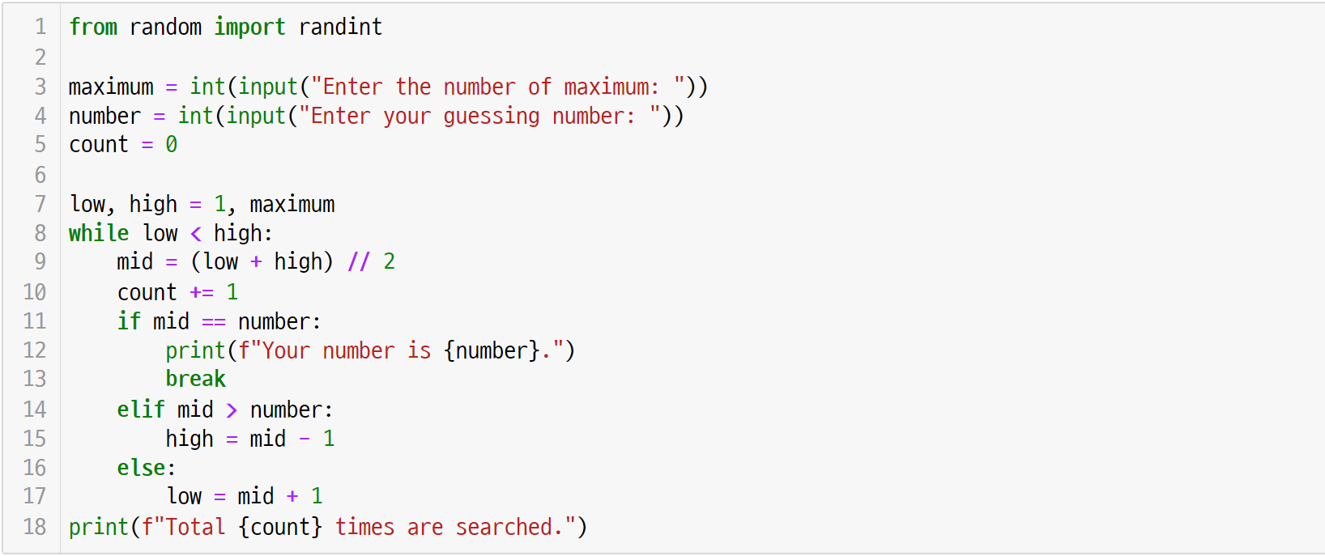
In the code for the number matching game, if the maximum is 100 and the number is 25, what is the output of count?

Samsung Innovation Campus Chapter 4. Algorithm 1 - Data Structures 10

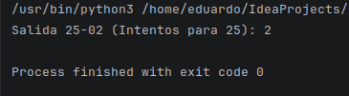

UNIT 26 Chapter 4 Quiz Hash Table

Q. 26-01

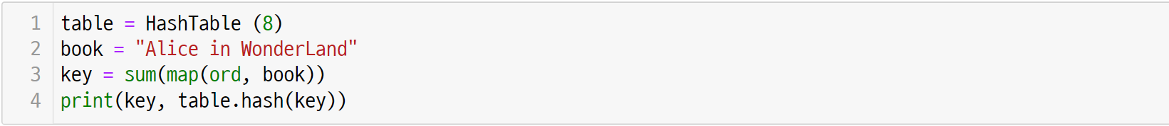
Using the hash function of the HashTable class, calculate the keyand hash keyof “Alice in Wonderland”as follows. (The key value is 1763.)

Samsung Innovation Campus Chapter 4. Algorithm 1 - Data Structures 11

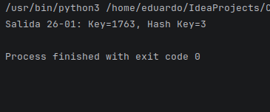

UNIT 26 Chapter 4 Quiz Hash Table

Q. 26-02

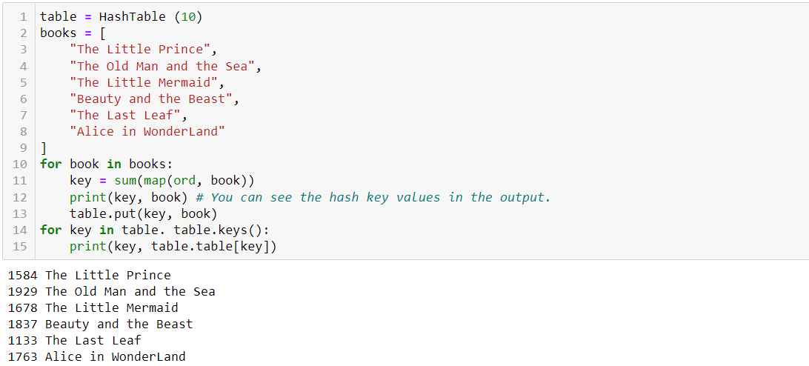
If a new bookshelf has 10 compartments, use the following code to find out which book is in each compartment. Refer to the hash key values in the output below.

Samsung Innovation Campus Chapter 4. Algorithm 1 - Data Structures 12

